**WEEK 02**

1. ***Create a user and provide the GRANT privileges to the user on the database then REVOKE the given privileges.***

CREATE USER 'dbms_user'@'localhost'

IDENTIFIED BY 'dbms_password';

GRANT ALL PRIVILEGES ON dbms.* TO 'dbms_user'@'localhost';

REVOKE ALL PRIVILEGES ON dbms.* FROM 'dbms_user'@'localhost';

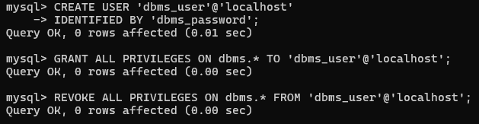

1. ***Insert any five records in the previous schema and apply the rollback. Also check the results.***

START TRANSACTION;

INSERT INTO Patient (Patient_ID, Ward_ID, Name, Age, Gender,

Admission_Date, Contact_Number) VALUES

(4, 1, 'Vikas', 45, 'Male', '2024-10-06', '9876543212'),

(5, 3, 'Meera', 28, 'Female', '2024-10-06', '9876543213'),

(6, 2, 'Raj', 32, 'Male', '2024-10-06', '9876543214'),

(7, 1, 'Pooja', 23, 'Female', '2024-10-06', '9876543215'),

(8, 3, 'Kabir', 36, 'Male', '2024-10-06', '9876543216');

ROLLBACK;

SELECT * FROM Patient WHERE Patient_ID >= 3;

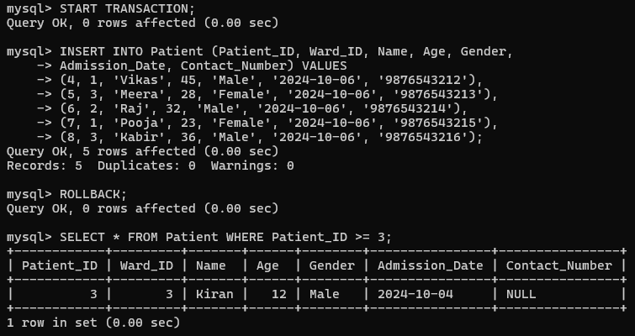

1. ***Add default, check, unique and not null constraints to the schema.***

ALTER TABLE Patient MODIFY Age INT NOT NULL;

ADD CONSTRAINT chk_age CHECK (Age > 0),

ADD CONSTRAINT unique_contact UNIQUE (Contact_Number),

MODIFY Gender VARCHAR(10) DEFAULT 'Unknown';

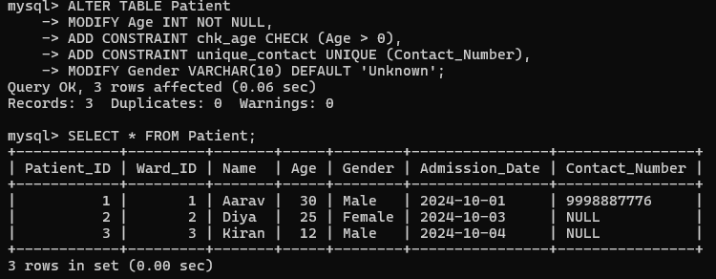

1. ***Insert NULL values and check the results.***

INSERT INTO Patient (Patient_ID, Ward_ID, Name, Age, Gender, Admission_Date, Contact_Number)

VALUES (9, 1, 'Priya', NULL, NULL, '2024-10-06', NULL);



1. ***Add duplicate value and try to make a column as primary key, check what happen to the table.***

INSERT INTO Patient (Patient_ID, Ward_ID, Name, Age, Gender,

Admission_Date, Contact_Number) VALUES (10, 2, 'Sohail', 29, 'Male', '2024-10-06', '9876543215');

ALTER TABLE Patient ADD PRIMARY KEY (Contact_Number);

